Rock – Paper – Scissors

# Input – process –output

In the main() in GameApp:

* Would you like to play (y/)?
* The game will proceed if you enter ‘y’, all other inputs will end the program gracefully.

To play a Game: PlayGames()

How many games would you like to play? (enter an integer) The number of games will be played in rounds.

In a round:

* the user enters a number (1 for rock/2 for paper /3 for scissors)
* random choice for system is created in CreateGo()
* user and system shape choice are translated to strings and stored in shapeStat[][]
* comparison made and wins, loses and draws tallied
* when the round is finished, round stats are displayed and all shapes chosen by user and system

When the games are all finished, game stats are displayed. Overall winner displayed.

Request to see how many games user would like to play, 0 to finish game.

# Class Diagram

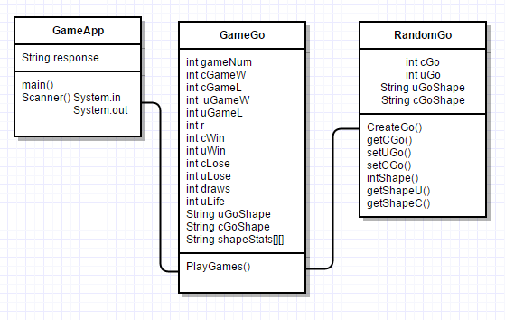

# Screen Shots

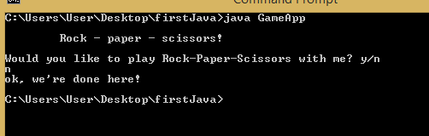

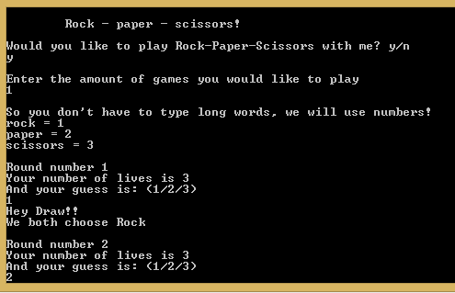

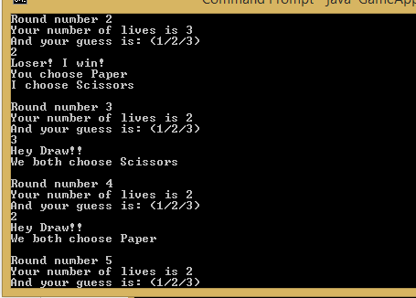

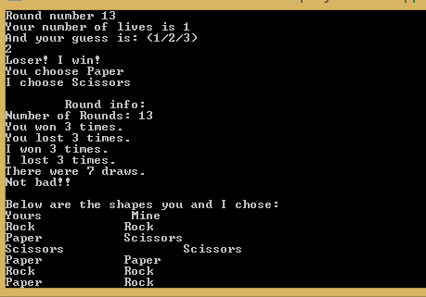

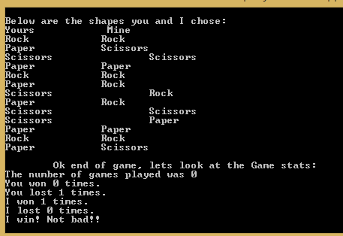

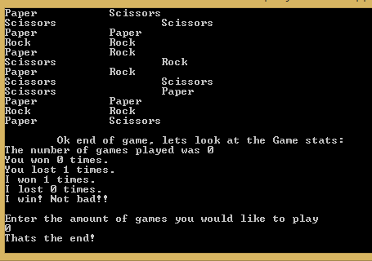



**National College of Ireland**

**Project Submission Sheet – 2014/2015**

**School of Computing**

|  |  |  |  |
| --- | --- | --- | --- |
| **Student Name:** | Emer Thornbury…………………………….……………………………………………………… | | |
| **Student ID:** | X13123174…….……………………………………………………………………………………… | | |
| **Programme:** | HDCLOUD  ……………………………………………………………… | **Year:** | 2014-2015  ……………………… |
| **Module:** | SWD……………………..……………………………………………………………………………….. | | |
| **Lecturer:** | …Adriana Chis……..….…………………………………………………………………………… | | |
| **Submission Due Date:** | 7/12/2014…………………….…….………………………………………………………………… | | |
| **Project Title:** |
|  | Emer Thornbury HDCLOUD2014_SDEV Rock-Paper-Scissors | | |
| **Word Count:** | ……………………………………………………………………………………………………………… | | |

I hereby certify that the information contained in this (my submission) is information pertaining to research I conducted for this project. All information other than my own contribution will be fully referenced and listed in the relevant bibliography section at the rear of the project.

ALL internet material must be referenced in the bibliography section. Students are encouraged to use the Harvard Referencing Standard supplied by the Library. To use other author's written or electronic work is illegal (plagiarism) and may result in disciplinary action. Students may be required to undergo a viva (oral examination) if there is suspicion about the validity of their submitted work.

|  |  |
| --- | --- |
| **Signature:** | Emer Thornbury…………………….……………………………………………………………… |
| **Date:** | 7/12/2014..…………………………………………………………………………………………… |

**PLEASE READ THE FOLLOWING INSTRUCTIONS:**

1. Please attach a completed copy of this sheet to each project (including multiple copies).

2. **You must ensure that you retain a HARD COPY of ALL projects**, both for your own reference and in case a project is lost or mislaid. It is not sufficient to keep a copy on computer. Please do not bind projects or place in covers unless specifically requested.

3 Assignments that are submitted to the Programme Coordinator office must be placed into the assignment box located outside the office.

|  |  |
| --- | --- |
| **Office Use Only** | |
| Signature: |  |
| Date: |  |
| Penalty Applied (if applicable): |  |